LF351 OpAmp used in Sallen Key Filter design

2x 0.1uF Caps, 2x 15k-ohm Resistors

180 ohm load resistor

Potentiometer used to control the PWM output, but not part of the final circuit

Arduino Uno, Pin 11, configure PWM output to frequency of 31.3kHz

Results:  
Duty Cycle of 25%:1.5V Duty Cycle of 68%: 3.5V

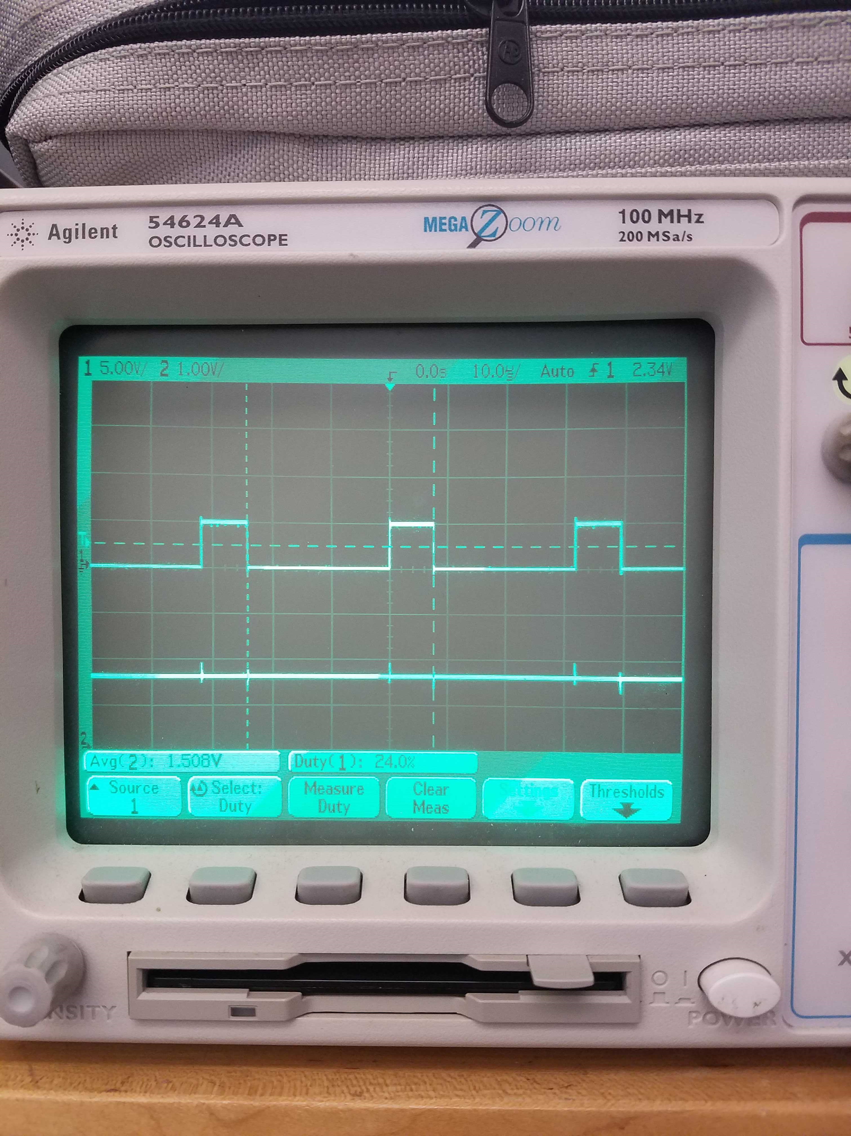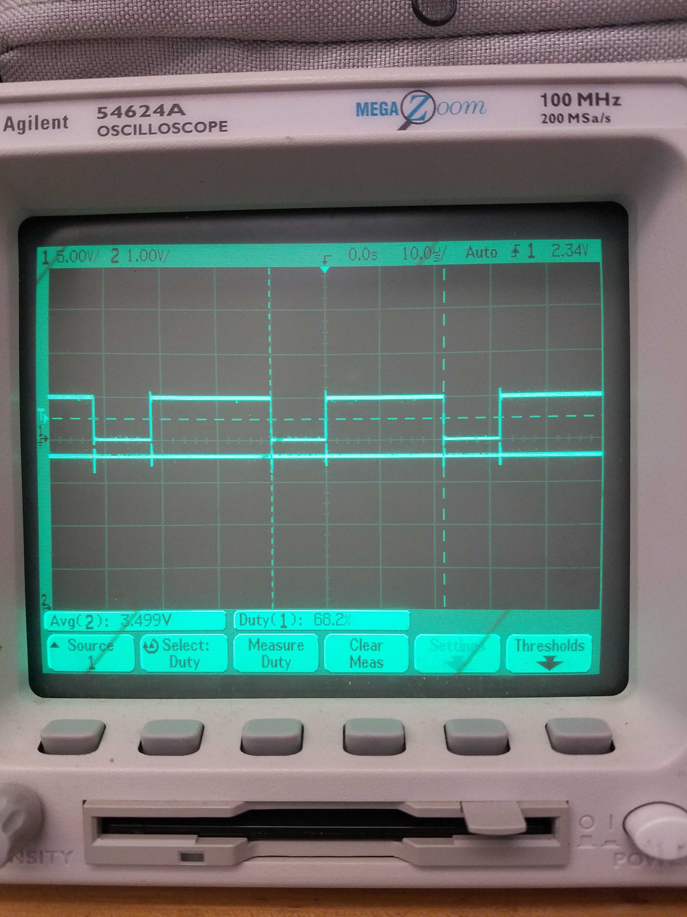

Conclusion:

In order to achieve these results on all 4 pins, we may need to replicate this circuit 4 times on a bread board / PCB

// Testing DAC from PWM conversions using a RC LP filter

/*

* Uno PWM pins:

* 490 Hz on Pin {3, 9, 10, 11}

* 980 Hz on Pin {5, 6}

*

* Leonardo PWM pins:

* 490 Hz on Pin {5, 6, 9, 10, 13}

* 980 Hz on Pin {3, 11}

*/

#define pwm_pin_490 10

#define pwm_pin_980 11

int pwm_val = 0;

#define pot_pin 0

int pot_val = 0;

void setup() {

// set PWM freq on UNO pins 3&11 to 31372.55Hz

TCCR2B = TCCR2B & B11111000 | B00000001;

// put your setup code here, to run once:

pinMode(pwm_pin_490, OUTPUT);

pinMode(pwm_pin_980, OUTPUT);

analogWrite(pwm_pin_490, 0);

analogWrite(pwm_pin_980, 0);

// while(!Serial);

// Serial.begin(9600);

// Serial.println("Hello Mr./Mrs. MSD Teammember");

}

void loop() {

// put your main code here, to run repeatedly:

pot_val = analogRead(pot_pin);

// Serial.print("\npot val: ");

// Serial.println(pot_val);

pwm_val = map(pot_val, 0, 1023, 0, 255);

// Serial.print("PWM val: ");

// Serial.println(pwm_val);

// analogWrite(pwm_pin_490, pwm_val);

analogWrite(pwm_pin_980, pwm_val);

delay(100);

}